**Determination of heavy metals (Mercury, Arsenic, Cadmium and Chromium) in the Birim River of Ghana**

**ABSTRACT**

Mining has long been an economic enterprise for Ghanaians especially the people occupying the middle belt of the country. Recently many mineral resources have been found in the country which has seen the influx of expatriates in Ghana engaging in the extraction of the various mineral resources. The mining industry nonetheless has been the major contributor to the Gross Domestic Product (GDP) of Ghana through foreign exchange earnings, investment and sectorial linkages. Even though the industry presents a good outlook for the country in terms of the financials, it comes with its own problem to the environment. This study is to analyse the chemicals (heavy metals) used by miners especially the artisanal miners popularly called “Galamseyers” to aggregate gold in the Birim River of Ghana in the Eastern Region. Trace metals in the samples will be analysed at the Ghana Standards Authority Laboratory in Accra Ghana. This will be conducted applying Inductive Couple Plasma (ICP) technique. The parameters the study sought to analyse were: Mercury, Cadmium, Arsenic and Chromium. During the study period 2023 the arsenic has been found to be <0.00143mg/l in all the sampling point. The observed concentration level of Arsenic in the sampling areas was found to be within the acceptable limits set by the GEPA and the USEPA. Chromium has been found to be less than the detection limit of 0.00021mg/l which is within the acceptable limit. Cadmium was found to be greater than the detection limit of 0.00007mg/l. the concentration level at sampling point A was found to be 0.0002mg/l, B was 0.0001mg/l and C being the control sample was 0.0002mg/l. But cadmium is within the acceptable limit allowable in water by the GEPA 1996 (0.003mg/l) and the USEPA (0. 5mg/l). Mercury was found to be below the detection limit and far below GEPA and USEPA allowable limits for ingestion in water. The heavy metals concentration in the Birim River in the Kyebi municipality which serves as the main water source for the community was found to be generally below the detection limits. The heavy metal concentration for cadmium was above the detection limit at all point sources but lower than the allowable limit set by the GEPA and USEPA. The study has shown that the concentration of Arsenic, mercury and Chromium in the Birim River was not detected, conforming to the GEPA and USEPA maximum Allowable limits. The research findings made it clear that the contamination of the Birim River by these metals to large extent is non-existent and its mainly due to the protection given to the river in the Kyebi township for the past three and half years following the ban on small scale and artisanal mining put in place by the government of Ghana in 2018. The people of Kyebi and its adjoining communities living along the Birim River should be watchful of their environment in order to prevent people with mining activities close the river to protect the integrity of the river for themselves and generations yet unborn.

*Key Words: galamsey (illegal miners), GEPA (Ghana Environmental Protection Agency), USEPA (United State of America Environmental Protection Agency), DL (Detection Limit), Birim River, Abuakwa, Kyebi Traditional Area, Osino, Anyinam, Ghana Standard Authority.*

**1.0 INTRODUCTION**

* 1. **BACKGROUND**

The mining sector is an important segment of the Ghanaian economy and has played a significant role in the country’s social economic development. Ghana mineral potential and the country’s contribution on global mineral output, especially gold is well acknowledged. According to Goldfields mining survey, Ghana was 9th leading producer of gold in the word and 2nd in Africa (Ghana chamber of mines 2011).

However, the increasing negative impact through continuous pollution of the water bodies and the land degradation cannot be quantified. Mining operations whether, small scale or large scale often involved the use of water, which impacts the water resources immediately and in the long term after closure of the operations (Gardener et al., 2015). A study conducted in 2007 by the commission of human rights and administrative justice revealed that, many rivers and streams which provided water for the mining communities have been destroyed, polluted or dried up. Illegal small-scale mining (popularly known as galamsey) has been identified as a major factor militating against sound environmental practices in the mining industry through the discharge of mercury and other pollutants into streams and rivers (Nasirudeen, 2015).

The presence of Gold deposits discovered in Kyebi in Abuakwa traditional area in the eastern region has attracted a lot of unemployed youth, small-scale and illegal mining ventures to the area. The activities of these individuals in the community and its environs are causing serious environmental havoc and destruction. Enormous quantities of the vegetation cover are gouged out, inverted and buried converting the natural terrain into raw, bare, lifeless spoil banks (Greenwood and Edwards, 1979). In Ghana, contaminations of surface and ground water bodies have particularly been experienced in gold mining communities (Davis et al., 1991) and Kyebi is not exempted from this phenomenon. This study is to assess the heavy metal (Mercury, Cadmium, Chromium and Arsenic) contamination of the Birim River in the Kyebi Traditional Area and compare the values against GEPA and USEPA values.

**1.2 STATEMENT OF THE PROBLEM**

“Water is life” has been used to describe how essential water is to the sustenance of life. The Birim river, once the pride of the communities located along it such as Kyebi, Osino, Anyinam, Bunso and other towns has been polluted to the extent that both Kyebi and Osino water treatment plants were shut down compelling people living in those communities to rely on sachet water as their source of drinking water. The situation prompted the government of Ghana to place two years ban on all forms of small-scale mining in the country until such a time that proper measures will be put in place to check the continuous pollution of the river bodies in the country due to small scale mining.

This study therefore sought to determine the presence of some selected chemicals used in mining by artisanal (Galamsey) miners that are in the categories of heavy metals in the Birim River two years after the ban. Water samples will be taken from the Birim river in kyebi. There will be two sampling 100 meters apart from each other along the Birim river and compare the results with the United State Environmental Protection Agency (USEPA) and Ghana Environmental Protection Agency (GEPA) to determine whether the towns perceptions of the pollution of the Birim river is tenable.

**HISTORY OF GOLD MINING IN GHANA**

Ghana has produced and exported gold for centuries. Most gold mining before the mid-nineteenth century was alluvial, wherein miners recovered gold from streams. In the late 1870s to early 1880s. The richest deposit, the Obuasi mine, was discovered by two Fante men by name Joseph Biney and Joseph Ellis who were later joined by another Fante man Joseph Brown. They sold the rights to the deposit cheaply to E. A. Cade because of British government's duplicitous behaviour. E.A. Cade, the founder of Ashanti Goldfields Corporation (AGC). Since the beginning of the twentieth century, modern mining in the Gold Coast has been pursued as a large-scale venture, necessitating significant capital investment from European investors. Under British colonial rule, the government controlled gold mining to protect the profits of European companies. The colonial government also restricted possession of gold as well as mercury, essential in recovering gold from the ore in which it is embedded. Following independence, foreign control of the sector was tempered by increasing government involvement under the Dr. Kwame Nkrumah regime (Clark, 1994).

In 1986 new mining legislation for the gold and diamond sectors replaced the previous complex and obsolete regulations, and a generous incentives system was established that allowed for external foreign exchange retention accounts, capital allowances, and a flexible royalties payment system. Since then the sector has benefited from a wave of fresh investment and by the early 1990s mining was the country's second highest foreign exchange earner (Clark, 1994).

More than twenty-one percent of gold production in the early 1990’s came from underground mines in western and Ashanti Region, with the remainder coming from river beds in Ashanti Region and Central Region (Clark 1994).

**2.2 ARTISANAL SMALL-SCALE MINING**

Small scale mining (SSM) may refer to the mining of ore deposits by individuals or groups of persons with little technical know-how and characterized by minimal or no mechanization. Some countries define SSM operations based on output and human resources needed (Coakley, 1999). However, the definition of SSM in Ghana has been based on the amount of capital and human resources needed. The Minerals and Mining Act 2006 (Act 703) of Ghana defines small scale gold mining operation as the mining of gold by any effective and efficient method that does not involve substantial expenditure by an individual or group of persons not exceeding nine in number or by a co-operative society made up of 10 or more persons. Small scale mining is recognized as a major contributor to national income and a pillar for poverty reduction in developing countries (Hentschel, Hruschka, & Priester, 2003). Small scale mining of minerals such as gold and diamond has provided employment for thousands of Ghanaians, especially indigenes of SSM communities, and has made significant contributions to the foreign exchange earnings of the country. In 2014, the sector produced 1.49 million ounces of gold representing 34.3% of Ghana's total gold output (Ntibrey, 2016). The sector has also helped in stemming rural-urban migration and provided raw materials for both foreign and local mineral industries. (Hilson, 2001). In Ghana, SSM has been carried out for hundreds of years. It is currently and widely operated in the country by both licensed operators and unlicensed miners popularly known as galamsey operators. According to the Ministry of Lands, Forestry and Mines of Ghana, the number of small-scale miners increased rapidly by 941.73% from 1984 to 2004 following the promulgation of the Small-Scale Gold Mining Law, PNDC Law 218 of 1989. The legalization was to revive the SSM sub-sector, facilitate supervision and minimize associated environmental hazards.

The nature of the mineral deposit generally dictates the mining method to be employed for exploitation. Historically, SSM methods for exploiting mineral deposits have involved the chisel and hammer, underground “ghetto”, and the dig and wash methods. More recent methods that involve the use of simple inexpensive Chinese-made equipment or more expensive and sophisticated machinery are being practiced. These recent methods brought about as a result of influx of Chinese nationals into Ghana are locally referred to as “changfa”, “more blade”, dredge, and alluvial washing plant methods in resident communities.

**2.3 HEAVY METALS**

Heavy metals are generally defined as metals with relatively high densities, atomic weights, or atomic numbers. Heavy metals are relatively uncommon in the Earth's crust but are present in many aspects of modern life. Some heavy metals such as Iron, Cobalt and Zinc are essential for human health whiles other are pollutants and are of concern because of their toxicities to humans. These elements are in general the transition metals, and some of the representative elements, such as lead and tin, in the lower right-hand corner of the periodic table. Heavy metals include essential elements like iron as well as toxic metals like cadmium and mercury. Most of them have a tremendous affinity for sulphur and disrupt enzyme function by forming bonds with sulphur groups in enzymes. Protein carboxylic acid (–CO2H) and amino (–NH2) groups are also chemically bound by heavy metals. Cadmium, copper, lead, and mercury ions bind to cell membranes, hindering transport processes through the cell wall (Manahan, 2000).

**2.3.1 HEAVY METAL CONTAMINATION**

Heavy metal pollution occurs when metals such as Cadmium, Arsenic, Chromium, lead, silver and zinc contained in excavated rock in underground mine meet water. These Metals are leached out from the rock surface and carried downstream. Although metals can become mobile in neutral pH conditions, leaching is particularly accelerated in the low pH conditions such as are created by Acid Mine Drainage.

**2.3.2 TOXICITY OF HEAVY METALS AND EFFECTS TO LIVING-ORGANISMS**

Heavy metals become toxic when they are not metabolized by the body and accumulate in the soft tissues. They may enter the human body through the water we drink, food we eat, the air we breathe, or even absorption through the skin in manufacturing, pharmaceutical, agricultural, industrial, or residential settings. Industrial exposure is common in adults and ingestion the most common route in children (Roberts, 1999). Heavy metal toxicity is frequently the result of long-term, low-level exposure to pollutants in the environment. Exposure to heavy metals has been linked with developmental retardation, cancer, kidney damage, and even death.

**2.4 CHARACTERISTICS OF SELECTED METALS IN THE STUDY**

**2.4.1 CADMIUM**

Cadmium is a chemical element with the symbol Cd and atomic number 48. Cadmium is number seven on ATSDR's toxic and hazardous substances "Top 20 list," and a by-product of the mining and smelting of lead and zinc. It is found in very low concentration in most rocks, as well as in coal and petroleum and often in combination with zinc. Geologic deposits of cadmium can serve as sources to groundwater and surface water, especially when in contact with soft, acidic waters. There is no evidence indicating its essentiality to humans (Hogan, 2010).

Pollutant cadmium in water may arise from industrial discharges and mining wastes. Cadmium is widely used in metal plating. Chemically, cadmium is very similar to zinc, and these two metals frequently undergo geochemical processes together. Both metals are found in water in the +2-oxidation state (Manahan 2000).

The effects of acute cadmium poisoning in humans are very serious. Among them are high blood pressure, kidney damage, destruction of testicular tissue, and destruction of red blood cells. (Manahan, 2000). It is believed that much of the physiological action of cadmium arises from its chemical similarity to zinc. Specifically, cadmium may replace zinc in some enzymes, thereby altering the stereo structure of the enzyme and impairing its catalytic activity. In aquatic ecosystems cadmium can bio accumulate in mussels, oysters, shrimps, lobsters and fish. The susceptibility to cadmium can vary greatly between aquatic organisms. Salt-water organisms are known to be more resistant to cadmium poisoning than freshwater organisms (Eshun, 2011). Rivers containing excess cadmium can contaminate surrounding land, either through irrigation for agricultural purposes, dumping of dredged sediments or flooding. It has also been demonstrated that rivers can transport cadmium for considerable distances, up to 50 km, from the source and is highly persistent in water, with a half-life of about 200 days (WHO, 1992).

**2.4.2 MERCURY**

Mercury is ranked third by the US Government Agency for Toxic Substances and Disease Registry of the most toxic elements or substances on the planet to arsenic and lead that continues to be dumped into our waterways and soil, spilled into our atmosphere, and consumed in our food and water.( Clifton JC 2007) Mercury is an avid gold collector, both constituting a kind of paste that enables one to obtain the solid material in an ore. This gives

Mercury an effectiveness that combined with its relatively low cost makes it a suitable method of implementation by artisanal miners, to extract the mineral from its natural occurrence, especially in deprived areas with economic and social constraints (Gasca, 2000).

Mercury Because of its toxicity, mobilization as methylated forms by anaerobic bacteria, and other pollution factors, mercury generates a great deal of concern as a heavy metal pollutant. Mercury is found as a trace component of many minerals, with continental rocks containing an average of around 80 parts per billion, or slightly less, of this element. Cinnabar, red mercuric sulfide, is the chief commercial mercury ore. Fossil fuel, coal and lignite contain mercury, often at levels of 100 parts per billion or even higher, a matter of some concern with increased use of these fuels for energy resources (Manahan, 2000).

Exposure to mercury in confined areas represents a high- risk source of toxicity. This type of exposure is applicable to incidents well reported in literature, such as the Minamata Bay contamination, and the food contamination in Iraq. Another uncertainty in determining mercury in the environment is that concentrations of the compound in non-polluted atmosphere and natural bodies of water can be so low, that it might not be possible to find a trace of them (Gasca 2000). To understand how mercury ends up causing health effects in humans is important to picture the global cycle of the compound on the environment. Mercury is an element of natural occurrence. Its chemical form can always change. It is emitted to the atmosphere coming from both human and natural sources, as elemental vapor (Hgo); eventually it will go back to earth through rain water, finally sinking in the sediments of earth, oceans and lakes. From there, microorganisms can transform inorganic mercury to methyl mercury. Eventually, due to its lipophilic characteristics, fish will end up absorbing the element, and biomagnification will occur through the food chain. Thus, in terms of human exposure in gold mining we have two main sources: Mercury vapor generated when burning the amal- gam (Outdoor or indoor), methyl mercury in fish, as part of diet among the people that inhabit an area where gold mining is done. (Gasca, 2000)

**Table 2.0 Summary of Effects Caused by Inhalation Exposure to Mercury Vapour**

|  |  |  |
| --- | --- | --- |
| Heavy exposure (hours –days) 5mg/l -10mg/l:  Respiratory distress, Damage in lung tissues, Excitabilities and Tremors. Renal failures may develop. | Moderate, repeated exposure (days – weeks) 0.05mg/l – few mg/l:  Behavioral and personality damages (e.g. shyness, insomnia) Mercury poisoning; gingivitis and salivation as the most common signs. | Lower, long lasting exposure (months – years) <0.05mg/l:  “Micro-Mercurialism”. Weakness, weight loss, memory disturbance and minor turbulence effect. |

**2.4.3 ARSENIC**

Arsenic is the 20th most abundant component of the Earth’s crust, and is widely distributed in rocks and soil, in natural waters, and in small amounts in most living things. It is a metalloid, which means that it can behave as a metal or as a non-metal. Arsenic is rarely found as a pure metal, but is often a component in sulphur containing minerals, the most common of which is arsenopyrite. Commercially, arsenic is produced as arsenic trioxide or as a pure metal. Arsenic may also be obtained from copper, gold, and lead smelter flue dust as well as from roasting arsenopyrite, the most abundant ore mineral of arsenic. However, arsenic is not recovered from these sources but is rather disposed of in an environmentally safe manner (SME 2015).

Inorganic arsenic is classified as a known human carcinogen by the International Agency for Research on Cancer. Consuming a large amount of arsenic over a lifetime can increase the risk of cancer in internal organs such as the bladder, lungs, and liver. In areas with naturally high levels of arsenic in the groundwater, arsenic poisoning from drinking water is a serious concern. Countries with elevated arsenic levels in their groundwater include Bangladesh, Taiwan, Mexico, Chile, China, and India. High concentrations of arsenic in lakes and streams can also be lethal to freshwater fish, invertebrates, and plant life. (SME2015).

Mining and extraction of As-bearing ore deposits will greatly enrich arsenic in all compartments of the biological cycle, i.e. water, soil, plant and living organism including human in the immediate vicinity of the deposits.

Arsenic is one of the most dangerous elements derived from mining activity. Human exposure to arsenic from mining activity has been recorded in many parts of the world including Thailand, Ghana, Greece, Austria, Australia, China, Brazil, Mexico, Canada and part of United States of America. Gold mining has always been accompanied by hazardous arsenic toxicity both in miners and in the close ecosystems (Moore 2012)

Arsenic poisoning from naturally occurring arsenic compounds in drinking water remains a problem in many parts of the world. Residents who consumed water that had arsenic level greater than 5μg/L for ten years or longer were more likely to report a diagnosis of skin cancer, adult onset diabetes, and cardiovascular disease than age-matched residents who drank water that contained no detectable arsenic (Dadzie 2012). Arsenic from drinking water can cause severe skin diseases including skin cancer; lung, bladder, and kidney cancers, and perhaps other internal tumours; peripheral vascular disease; hypertension; and diabetes. It also seems to have a negative impact on reproductive processes (infant mortality and weight of new born babies)

**2.4.4 CHROMIUM**

Chromium (Cr) is a grey, hard metal most commonly found in the trivalent state in nature. Hexavalent (chromium (VI)) compounds are also found in small quantities. Chromite (FeOCr2O3) is the only ore containing a significant amount of chromium. The ore has not been found in the pure form; its highest grade contains about 55% chromic oxide (IARC 1980).

Cr(VI) in the forms of chromate (C r O4 2 −), dichromate (C r O4 2 −), and CrO3 is considered the most toxic forms of chromium, as it presents high oxidizing potential, high solubility, and mobility across the membranes in living organisms and in the environment. Cr (III) in the forms of oxides, hydroxides, and sulphates is less toxic as it is relatively insoluble in water, presents lower mobility, and is mainly bound to organic matter in soil and aquatic environments. Moreover, Cr (III) forms tend to form hydroxide precipitates with Fe at typical ground water pH values. At high concentrations of oxygen or Mn oxides, Cr (III) can be oxidized to Cr (VI) (Oliveira 2012)

As Cr (VI) and Cr(III) present different chemical, toxicological, and epidemiological characteristics, they are differently regulated by EPA, which constitutes a unique characteristic of Cr among the toxic metals. Cr (VI) is a powerful epithelial irritant and also considered a human carcinogen. Cr (VI) is also toxic to many plants aquatic animals, and microorganisms. Contrarily to Cr (VI), Cr (III) is considered a micronutrient in humans, being necessary for sugar and lipid metabolism and is generally not harmful. In plants, particularly crops, Cr at low concentrations (0.05–1 mg L−1) was found to promote growth and increase yield, but it is not considered essential to plants. In this context, accumulation of chromium in edible plants may represent a potential hazard to animals and humans. (Oliveira 2012)

The average concentration of chromium in rainwater is in the range 0.2–1 ¬g/litre. Natural chromium concentrations in seawater of 0.04–0.5 µg/litre have been measured. In the North Sea, a concentration of 0.7µg/litre was found. The natural total chromium content of surface water is approximately 0.5–2 µg/litre and the dissolved chromium content 0.02–0.3 µg/litre. Chromium concentrations in Antarctic lakes increase with depth from <0.6 to 30µg/litre. Most surface waters contain between 1 and 10 µg of chromium per litre. In general, the chromium content of surface waters reflects the extent of industrial activity. In surface waters in the USA, levels up to 84µg/litre have been found; in central Canada, surface water concentrations ranged from 0.2 to 44 µg/litre [data from the National Water Quality Data Bank (NAQUADAT), Inland Waters Directorate, Environment Canada, 1985]. In the Rhine, chromium levels are below 10 µg/litre(14), and in 50% of the natural stream waters in India the concentration is below 2 µg/litre. In general, the chromium concentration in groundwater is low <1µg/litre (WHO 1996).

**2.5 REVIEW OF INSTRUMENTAL TECHNIQUES FOR METAL ANALYSIS**

**2.5.1 ATOMIC ABSORPTION SPECTROSCOPY**

In atomic absorption (AA) spectroscopy, absorption of a photon results in excitation of an electron from a lower to higher energy atomic orbital (AO). An instrument measures the absorbance, A, which is defined as the logarithm of the ratio of incident to transmitted radiant power of the photon beam, A = log (P0 ÷ P), at a wavelength specific to the element of interest. Samples are typically analysed using a spectrophotometer. In atomic emission (AE) spectroscopy, thermal or electrical energy from an arc, flame, spark, or plasma is used to excite an electron from a lower to higher energy AO; when the excited electron returns to its original AO (i.e. the ground state), it may do so by emitting a photon. The instrument measures the intensity, I, of these emitted photons as a function of wavelength. Because AO energies are well-defined, atomic absorption and emission spectra consist of discrete, narrow lines. This allows the concentration of metallic elements in different samples to be determined selectively, with lower limits at or below 1 mg/L (1 ppm). Techniques such as graphite furnace atomic absorption spectrophotometry (GFAAS) allow concentration to be measured down to µg/L (ppb) levels. Actual limits-of-detection vary with element, technique, and sample matrix. (Stone 2012)

**2.6.2 FLAME ATOMIC ABSORPTION SPECTROMETRY (FAAS)**

Flame atomic absorption is a very common technique for detecting metals and metalloids in environmental samples. It is very reliable and simple to use. The technique is based on the fact that, ground state metals absorb light at specific wavelengths. Metal ions in a solution are converted to atomic state by means o f a flame. Light of the appropriate wavelength is supplied, and the amount of light absorbed can be measured against a standard curve. Basic Principle The technique of flame atomic absorption spectroscopy (FAAS) requires a liquid sample to be aspirated, aerosolized, and mixed with combustible gases, such as acetylene and air or acetylene and nitrous oxide. The mixture is ignited in a flame whose temperature ranges from 2100 to 2800 °C.

During combustion, atoms of the element of interest in the sample are reduced to free, unexcited ground state atoms, which absorb light at characteristic wavelengths. The characteristic wavelengths are element specific and accurate to 0.01 - 0.1 nm. To provide element specific wavelengths, a light beam from a lamp whose cathode is made of the element being determined is passed through the flame. A device such as photomultiplier can 49 detects the amount of reduction of the light intensity due to absorption by the analyte, and this can be directly related to the amount of the element in the sample. This instrument in particular is designed to operate either with a tlame or with a graphite furnace. The graphite furnace is additionally equipped with an auto sampler. Flame atomic absorption hardware is divided into six fundamental groups (light source, atom cell, monochromator, detector, amplifier, and signal display-data station) that have two major functions: generating atomic signals and signal

processing. Signal processing is a growing additional feature to be integrated or externally fitted to the instrument.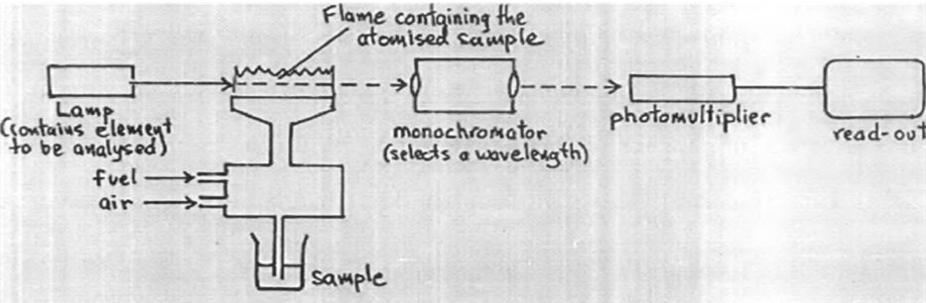

A cathode lamp (light source), shown in the figure, is a stable light source, which is necessary to emit the sharp characteristic spectrum of the element to be determined. A different cathode lamp is needed for each element, although there are some lamps that can be used to determine three or four different elements if the cathode contains all of them. Each time, a lamp is changed; proper alignment is needed in order to get as much light as possible through the flame, where the analyte is being atomized, and into the monochromator. The atom cell is the part with two major functions: nebulization of sample solution into a fine aerosol solution, and dissociation of the analyte elements into free gaseous ground state form. Not all the analyte goes through the flame, part of it is disposed. As the sample 50 passes through the flame, the beam of light passes through it into the monochromator. The monochromator isolates the specific spectrum line emitted by the light source through spectral dispersion, and focuses it upon a photomultiplier detector, whose function is to convert the light signal into an electrical signal (Haswell, 1991).

**2.6.3 INDUCTIVELY COUPLED PLASMA OPTICAL EMISSION SPECTROSCOPY**

A variety of sample types can be analysed by Inductively Coupled Plasma Optical Emission Spectroscopy (ICP-OES), including aqueous and organic liquid and solid samples. These samples have to be brought into a state that the ICP and the instrument as a whole can process for elemental analysis. The most typical sample form is a liquid. A liquid sample is introduced using a peristaltic pump to ensure constant flow. Commonly, a high-speed flow of gas (usually Argon gas) is used to shatter small droplets of liquid into an aerosol. This aerosol is then introduced into a spray chamber which removes the larger droplets. Only the fine aerosol is allowed to enter the plasma. Solid samples are typically ablated into small particles either using a laser or spark ablation system or then transported directly to the plasma. Aqueous samples can be introduced into a plasma directly, and often without dilution. They are typically acidified with Nitric Acid (HNO3) to ensure that their elemental components remain in solution. A standard sample introduction system usually consists of a concentric nebulizer and a cyclonic spray chamber. Concerning particles in solution, a standard nebulizer can handle particle sizes of up to one third of the capillary diameter.

For each sample analysed, two wavelengths were selected for each element. The aerosol sprayed into the plasma. The particles are excited by the source of energy (torch) and they lose energy by emission. This emission is proportional to the concentration of the element present. Since the wavelengths are two, the machine displays two concentrations at those wavelengths. The sample is analysed three repeated times and the average repetitive concentration is chosen considering the standard deviation and %RSD.

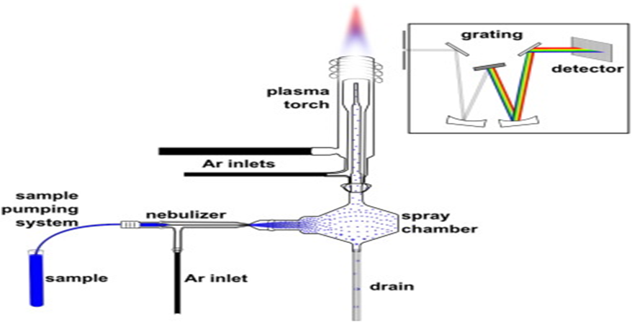

**Figure 2.1 Schematic diagram of ICP-OES Main Process**

**3.0 STUDY AREA**

**3.1 GEOGRAPHICAL LOCATION**

The East Akim Municipal is in the central portion of Eastern Region with a total land area of approximately 725 km2. It used to be the second largest of the 15 districts in Eastern Region until 2004 when the Atiwa district was carved out of it. The Municipal is bounded by six districts namely Kwahu South District to the North, Atiwa District to the North-West, Kwaebibirem District to the South-West, Fanteakwa District to the East and New Juaben Municipal and Suhum-Kraboa-Coaltar Districts to the South. The Municipal capital, Kibi, is 55 km from Koforidua, 105 km from Accra and 179 km from Kumasi. (Businessghana.com)

Fig 3: Map of East Akim Municipal Municipality

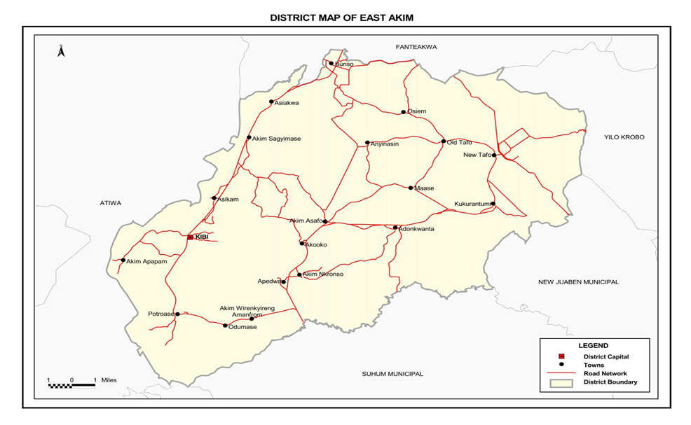

**Source: Ghana Statistical Service, GIS**

**3.2 CLIMATE**

The municipality lies in the west semi-equatorial zone which is characterized by two mains rainfall seasons occurring in June and October; the first rainy season starts from May to June and the second from September to October. The mean annual rainfall is between 125 mm and

175 mm. The dry seasons are distinct starting between November and late February. Temperatures are found to be uniform ranging between 26-degree Celsius in August and 30-degree Celsius in March. Relative humidity is generally high throughout the year, ranging between 70% - 80% in the dry season and 75% - 80% in the wet season (District Analytical report 2010).

**3.3 THE BIRIM RIVER**

The Birim River is one of the main tributaries of the Pra River in Ghana and the country's most important diamond-producing area, flowing through most of the width of the Eastern region. The river rises in the east of the Atewa Range, flows north through the gap between this range and the Kwahu Plateau, then runs roughly south-west until it joins the Pra. It gives its name to the Birimian rock formation, which yields most of the gold in the region. (Mining review Africa 2004)

The river rises in the Akim district of the Eastern Region of Ghana, in the Atiwa Range forest, which rises to 780 m. The surrounding lowlands are about 180-200 m above sea level. The Birim river gravels hold gold which has long been extracted through Placer or panning mining used in making ornaments and for trans-Saharan trade long before the Europeans discovered the Gold Coast. (Patrick J. Munson 1980).

The communities around the river use the water for drinking and other domestic purposes without treating it prior to using it.

**3.4 EXPERIMENTAL METHODS**

This chapter describes the various methods, other auxiliary materials employed, and the reagents used in this work. All chemicals to be used are of the analytical grade and therefore need not to be purified unless otherwise stated. The determination of the trace metals in the samples will be carried out at the Ghana Standards Authority Laboratory in Accra Ghana. In this work, trace metal analysis will be conducted applying Inductive Couple Plasma (ICP) technique.

**3.4.1 SAMPLING SITES**

Two different sampling points along the Birim River in Kyebi municipality was selected for the study. The code A, B and C were used to indicate the sampling points. Two sampling points 100 meters apart were used for this study. Sampling point A was taking at the point where the main water treatment plant takes their feed water. Sampling point B was 100 meters away from the sampling point A. A treatment water sample C was also taken from the municipality to be used as the reference sample.

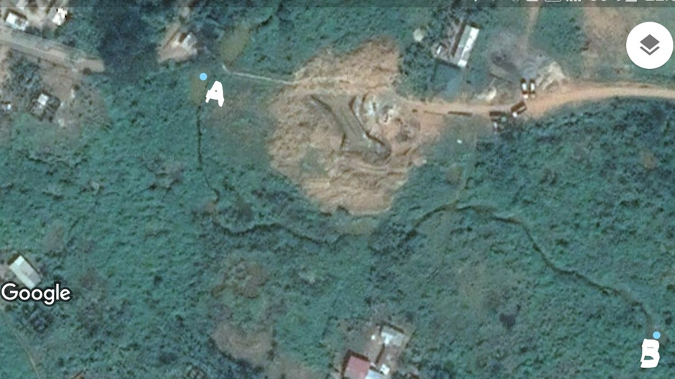

**Fig 3.1 satellite view of the sampling sites in the kyebi municipality**

**3.4.2 WATER SAMPLING**

The water samples were collected at two different sampling points to serve as the subject of study. The Water samples were collected at the water surface using 500ml PET bottles. The water sampling bottles was rinsed twice with the water (Birim river) before sampling was carried out at each sampling point. The water samples were collected by tilting the bottles against the direction of the river flow. After sampling, the water samples were acidified, and the bottles were tightly covered with caps. Identification label was fixed on each of the bottle and placed in an ice chest and transported to crystal scientific laboratory for analysis. Acidification of samples was necessary to keep the metal ions from precipitating and to minimize adsorption of dissolved species onto the sample containers. The samples were then analysed for traces of metals such as Arsenic, cadmium, chromium and mercury using Inductively Coupled Plasma Optical Emission Spectroscopy (ICP-OES).

The samples for ICP were digested with 68% nitric acid (HNO3) before analysis. This is necessary to keep the required species, of cations in the solution to avoid changes. (Mendham et al., 2002).

**3.5 SAMPLE ANALYSIS**

**3.5.1 TREATMENT OF WATER SAMPLES**

Each sample was mixed thoroughly by shaking and 485 ml transferred into a conical flask. A 15.0 ml 68% concentrated HNO3 was then added. for the determination of levels of heavy metals to stabilize the ions in the solution. This is to prevent adsorption of metal ions on the sides of the container and minimize precipitation of metal ions (APHO, 1992).

**3.5.2 PARAMETERS DETERMINED**

The parameters determined were Mercury, Chromium, Cadmium and Arsenic which are part of heavy metals.

**3.5.3 INDUCTIVE COUPLED PLASMA (ICP) ANALYSIS**

20ml of the digested samples from each sampling point was then used for the analysis in an inductively coupled plasma-optical emission spectroscopy (iCAP 7400 ICP-OES). Standard solutions were prepared from 1000ppm multipurpose element solution. 1ppm and 2.5ppm each and used as the reference standards. The wavelength used for analyzing the samples are 214.4nm for Cadmium, 193.7nm for Arsenic, 283.5nm for Chromium and 194.2 and 184.9nm for mercury. Because of the delicate nature of mercury analysis using the ICP, it is done alone using two wavelengths as suggested by the ICP machine itself so as to be sure of the results. The correct wavelength to use is highlighted by the machine.

**RESULTS AND DISCUSSION**

**4.1 RESULTS**

In order to achieve the aim and objective of this study, the surface water samples were collected from two sampling points in the Birim River and a controlled sampled being a treated water sample from within the catchment area. These samples were then subjected to a laboratory analyses to assess the level of some heavy metal. The results obtained within the period of assessment at the sampling sites are shown in table 4.

**TABLE4. ESTIMATION OF HEAVY METALS IN BIRIM RIVER BY ICP-OES TECHNIQUE**

**Metals in water (Dissolved) by ICP-OES USEPA Methods: 6010 and 200.7**

|  |  |  |  |  |  |
| --- | --- | --- | --- | --- | --- |
| Parameters | Unit | DL | A | B | C |
| Arsenic | mg/L | 0.00143 | <DL | <DL | <DL |
| Chromium | mg**/**L | 0.00021 | <DL | <DL | <DL |
| Cadmium | mg/L | 0**.**00007 | 0**.**0002 | 0.0001 | 0.0002 |
| Mercury | mg/L | 0.00014 | **<**DL | <DL | <DL |

**The concentration levels of 4 heavy metals in the Birim River at Kyebi in the East Akim Municipality during the study period 2019 by ICP-OES technique are discussed below**.

**4.2 DISCUSSION OF RESULTS**

**4.2.1 ARSENIC**:

During the study period 2019 the arsenic has been analyzed by using the ICP-OES technique and has been found to be <0.00143mg/l in all the sampling point. The maximum acceptable limits for arsenic as per USEPA and GEPA is 0.01mg/l. the observed concentration levels of Arsenic in the sampling areas was found to be with the acceptable limits set by the GEPA and the USEPA.

**4.2.2 CHROMIUM**:

During the study period 2019 chromium has been analyzed by using the ICP-OES technique and has been found to be less than the detection limit of 0.00021mg/l which is within the acceptable limit of USEPA and GEPA 1996 allowable limit of 0.05mg/l

**4.2.3 CADMIUM**:

During the period the cadmium has been analyzed by using the ICP-OES technique and has been found to be greater than the detection limit of 0.00007mg/l. the concentration level at sampling point A was found to be 0.0002mg/l, B was 0.0001mg/l and C being the control sample was 0.0002mg/l. nonetheless these values recorded for cadmium is within the acceptable cadmium limit allowable in water by the GEPA 1996 and the USEPA of 0.003mg/l and 0. 5mg/l.

**Figure 4.1 Cadmium concentrations in the Birim River**

**4.2.4 MERCURY**

The level of mercury concentration in all the samples were found to be below the detection limit of 0.00014mg/l which is far below the USEPA and GEPA allowable limits of 0.002mg/l and 0.001mg/l respectively.

**CONCLUSION AND RECOMMEDATION**

**5.1 CONCLUSION**

The heavy metals concentration in the Birim River in the Kyebi municipality which serves as the main water source for the community was found to be generally below the detection limits. The heavy metal concentration for cadmium was above the detection limit at all point sources but lower than the allowable limit set by the GEPA and USEPA,

The study has shown that the concentration of Arsenic, mercury and Chromium in the Birim River was not detected, conforming to the GEPA and USEPA maximum Allowable limits. The research findings made it clear that the contamination of the Birim River by these metals to large extent is non-existent and its mainly due to the protection given to the river in the Kyebi township for the past three and half years following the ban on small scale and artisanal mining put in place by the government of Ghana in 2016.

**5.2 RECOMMENDATION**

The following recommendation is based on the research findings.

• To sustain the good health of the Birim River at kyebi continuous monitoring of all activities along the banks of the river is required by both the authorities and the people in the area.

• The banks of the river must be protected against encroachers and private estate developers in the Kyebi Township to prevented future pollution of the Birim River.

• The ban on artisanal small scale on the banks of the river must be sustained.

• Since the Birim River the Kyebi Township serves as the main source of water supply to the people of the area, analysis of the river should be carried out to ascertain whether the water is of good health and good for use.

• Proper education should be given to the community on the dangers of galamsey on water bodies and the effect on their health if they drink untreated water, by face to face interaction, communication centers, and social media for proper understanding.

**REFERENCES**

1. AFRICA GEOLOGICALLY UNDER EXPOSED". Mining Review Africa. 2004. Archived from the original on December 2, 2008. Retrieved 2009-03-17.
2. APHA (1985). Standard Methods for the Examination of Water and Wastewater. (15th Edition) Washington D.C American Public Health Association. p. 1134.
3. APHA, (1992). Standard Methods For The Examination of Water and Waste Water. American Public Health Association, 18th ed., Academic Press. Washington D.C.
4. pp. 214-218,
5. Adriana del Pilar Gasca Álvarez (2000). Environmental Exposure to Mercury in Gold Mining: Health Impact Assessment in Guainía, Colombia, 2000 ;236 – 40.
6. Behnam Keshavarzi. Farid Moore. Fatemeh Rastmanesh. Maryam Kermani (2012) Arsenic in the Muteh gold mining district, Isfahan, Iran. Published online 21st February 2012 at https://www.researchgate.net/publication/257793827_Arsenic_in_the_Muteh_gold_mining_district_Isfahan_Iran
7. Chromium, nickel and welding. Lyon, International Agency for Research on Cancer, 1990, pp. 463–474 (IARC Monographs on the Evaluation of Carcinogenic Risk of Chemicals to Humans, Vol. 49)
8. Clifton JC.(2007), 2nd Mercury exposure and public health. Pediatr Clin North Am. 2007;54(2):237–269.[PubMed]
9. Clark, Nancy L. (1994). "Mining and Petroleum Industries". A Country Study: Ghana (La Verle Berry, editor). Library of Congress Federal Research Division (November 1994).
10. Coakley, G. (1999). The mineral industry of Ghana (pp. 17.1e17.11).Washington, DC: US Geological Survey, Minerals Information.
11. Dr. David C. Stone (2012), Atomic Spectroscopy; Instrumentation, Techniques, and Theory. Available athttps://www.chem.utoronto.ca/coursenotes/analsci/atomic/index.html
12. Davies C. A., Tomlinson K, and Stephenson T, (1991). Heavy metals in River Tees estuary sediment. Environ. Technology, 12: 961-972.
13. Esi Saawa Dadzie (2012) Assessment of Heavy Metal Contamination of the Densu River, Weija from leachate: pp16-17.
14. Francis Bismark Eshun (2011) Distribution of heavy metals in the Fosu Lagoon -cape coast published. Msc. Thesis Kwame Nkrumah University of Science and Technology.pp 13
15. Guidelines for drinking-water quality, 2nd ed. Vol. 2. Health criteria and other supporting information. World Health Organization, Geneva, 1996. Chromium in drinking water pp 3
16. Gardner, A., Duff, N., Ainuson, K., & Manteaw, S. (2015). Regulating Mining Water Use and Impacts in Ghana:Comparing Australian and Ghanaian Law for Reform Ideas, Australia: s.n.
17. Ghana Chamber of Mines. (2006). Draft Minerals and Mining Policy of Ghana
18. Ghana statistical report, population and housing census 2010, District Analytical Report, East Akim Municipal. pp 1. October 2014.
19. Ghana statistical report, population and housing census 2010, District Analytical Report, East Akim Municipal. pp 3-4. October 2014.
20. Greenwood, J.N. and J.M.B, Edwards, (1979). Human Environments and Natural Systems. 2nd Edn., Duxbury press, California, pp: 153-162,170
21. Helena Oliveira,(2012) “Chromium as an Environmental Pollutant: Insights on Induced Plant Toxicity,” Journal of Botany, vol. 2012, Article ID 375843, 8 pages, 2012. https://doi.org/10.1155/2012/375843.
22. Hentschel, T., Hruschka, F., & Priester, M. (2003). Artisanal and small scale mining: Challenges and opportunities (p. 94). UK: International Institute for Environment and Development (IIED).
23. Hilson, G. (2001). A contextual review of the Ghanaian small-scale mining industry. Mining, Minerals and Sustainable Development, 76 pp.
24. Hogan, C.M. (2010). Encyclopedia of Earth, National Council for Science and the Environment, Washington DC.
25. https://epi.publichealth.nc.gov/oee/docs/HeavyMetalsInfo.pdf 13/10/2018. 14:15pm
26. Manahan, Stanley E,(2000) “Frontmatter” Environmental Chemistry, Heavy metals, pp-203
27. Mendham J, Denney RC, Thomas MJ (2002). Vogel’s Textbook of Quantitative Chemical Anaslysis. (6th Edition) Pearson Education Ltd, India, p. 197.
28. Nasirudeen, A. F. (2015) Management, Water Resource. Available at Mikashini.com/blog/2015/04/mining-enemy-to-ghanas-water-resources-part-2/. Retrieved on 27/12/2018 at 7:06am
29. Ntibrey, B. K. (2016). Small scale mining sector in Ghana & Minerals Commission's role in managing it. In Presentation at stakeholder sensitization workshop Tarkwa on November 23, 2015 (p. 43).
30. Society for Mining, Metallurgy & Exploration 2015, The Role of Arsenic in the Mining Industry:pp http://me.smenet.org/docs/Publications/ME/Issue/TheRoleofArsenicintheMiningIndustry.pdf
31. Roberts, J. R. (1999). Metal toxicity in children. In Training Manual on Pediatric Environmental Health: Putting It into Practice. Emeryville, CA: Children's Environmental Health Network (http://www.cehn.org/cehn/trainingmanual/pdf/manual-full.pdf).
32. Some metals and metallic compounds. Lyon, International Agency for Research on Cancer, 1980 (IARC Monographs on the Evaluation of the Carcinogenic Risk of Chemicals to Humans, Vol. 23)
33. Veiga M, Meech J. (1999). Reduction of Mercury emissions from gold mining activities andremedial procedures for polluted sites. In: Azcue J. (Editor). Environmental Impacts on Mining activities: emphasis on mitigation and remedial measures. Berlin: Springer-Verlog - Heidelberg Publishers.
34. https://www.businessghana.com/site/directory/district-assembly/16119/East-Akim-Municipal-Assembly. 13/10/2018 20:38
35. Patrick J. Munson (1980). "Archaeology and the Prehistoric Origins of the Ghana Empire". Journal of African History. 21: 457–466.